DNR Intranet / Purchasing /Order of Precedence: Plus {extra notes}
We want to start with your role…..the Buyer. Buyers play an important role in ensuring needed goods and services are procured in an efficient and economical manner while gaining and retaining public trust and confidence. So, what does this mean? As a Buyer, you are not just a paper pusher. You are to ensure that Purchasing rules are followed because most stem from Georgia law. We should always listen to our supervisors; however, sometimes they don’t know the details of all the rules. They are not trying to do something wrong, they just don’t know. It is our job as Buyers to be in the know and to help them know the right steps to take. We should do our best to get the best goods/services at the best prices in plenty of time to meet our users’ (or bosses) needs.
I know you are asking, where do I begin when my boss says he or she needs something?? When your unit needs something, you need to consider the type of product and the total dollar amount you need to purchase. To determine where to purchase, you should always start at the top of the pyramid and work down until you get to the tier that gets you what you need when you need it.
Is this item on…..

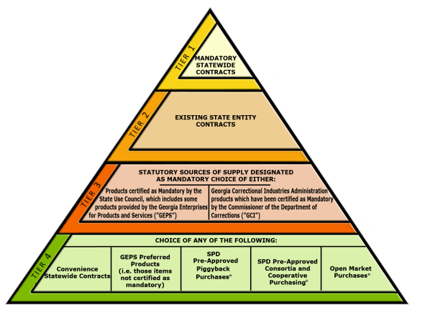
GCI is Intergovernmental

Statewide Contract (SWC)**

**
GEPS or Intergovernmental

Agency Contract (AC)

This is known as the Order of Precedence, which if you attended DOAS’ Fundamentals of Purchasing you may remember it.
Tier 1.Is the item(s) or service(s) available from a Mandatory Statewide Contract (SWCM)? OR Convenience.

DOAS has designated certain products as only available for purchase from select vendor(s) {Mandatory}. You must order from this vendor.
An example today, January 2020, would be Paper or Hospitality Products such as toilet tissue, hand towels, trash bags, which are Mandatory to purchase from Southeastern Paper Group.
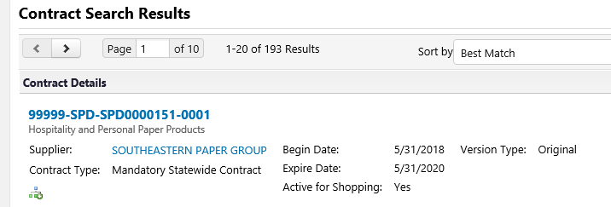

There are also Statewide Contracts listed as Convenience Contracts, which in most instances we recommend you treat as Mandatory.
An example today would be Staples. Purchase through the TeamGA Marketplace / Virtual Catalog / Staples Punchout Link for Office Supplies.

Stay Current with the latest Statewide Contracts by using TeamGA Marketplace to review or search for products. Do not assume that last years’ vendor is still the preferred vendor this year.

There are no dollar amount limits on Statewide Contract purchases, IE, $25,000 limit does not apply.

Tier 2 - Is the item(s) or service(s) available from a State Entity (Agency) Contract?
Individual State Agencies can also Bid products which may be unique to their own business and award them as an Agency Contract, which are valid for 1 year with up to 4 optional additional renewal years.

These Agency Contracts are NOT in TeamGA Marketplace.
State Parks -Agency Contract details are listed on Staff Resources/ Purchasing/ Agency Contracts. Typical unique products to Parks that we have on Contract are: Cottage housewares & linens, ParkPass Daily Envelopes, Recreational Equipment, Uniforms, etc.
For other DNR Family Agency Contracts that we can also utilize, check out DNR Intranet Purchasing Information page.
There are no dollar amount limits on Agency Contract purchases, IE, $25,000 limit does not apply.
**A PSoft Purchase Order is required for Agency Contract vendors.

Tier 3. Is the item(s) or service(s) designated as mandatory from Georgia Enterprises for Products and Services?
- Georgia Enterprises for Products and Services

Tier 3B. Is the item(s) or service(s) provided by an Intergovernmental Agreement/Agency?
Agencies such as GCI {GA Correctional Industries}, Department of Corrections, and Department of Labor are intergovernmental agencies and as such the $25,000 purchase limit does not apply to these types of agencies.
Parks Division purchases from GCI are our Internal and External metal signs, picnic tables, grills & fire rings, cleaning supplies and office furniture.
Department of Labor (DOL) provides printing services.

Tier 4.
Is the item(s) or service(s) designated as preferred products from Georgia Enterprises for Products and Services, Georgia Industries for the Blind or on a Convenience Statewide Contract OR State Purchasing Division Approved Piggyback Purchase?

- Georgia Enterprises for Products and Services
- Georgia Industries for the Blind
- Convenience Contracts (This is for quick reference only) (updated 3/4/20) **see notes above Tier 1

- Piggyback= DOT Aggregate Contract- DOAS has given DNR approval to piggyback off of the current DOT aggregate contract. There are three vendor on the contract and their contract information is located below. When placing orders be sure to let them know to give you DOT contract pricing. All pos should be coded ACP-approved piggyback purchase.
  - DOT Piggyback Approval
    - Aggregate USA
    - Martin Marietta
    - Vulcan

Open Market Purchase < $25,000
When all of the above is not applicable to your purchase, then it is considered an Open-Market Purchase and you can obtain the item from any vendor. Best practice is always shop for the best price and keep documentation especially on larger competitive products.

> $25,000
HOWEVER, the second criteria mentioned in the beginning was how much are you going to spend.
IF the single purchase or in our case (Parks Division) as a group of sites is purchasing the same item(s) or service (s) and the total is greater than $25,000 either singularly or collectively, then a Bid may be required. Contact your Region Office and/or Pam Meditz in Headquarters about your specific issue if unsure.

SEE DNRintranet/Purchasing for > $25,000 Emergency Procedures

